11.3 Area –

To create these, copy the shapes from XL into paint.net. Use paint.net to give them the right color background, then paste them into this document to label them. Most of these were captured at 110%

GP2

SEE THE FILE “qs11.3-4 barn shaped house” for the version with the barn

60

12

24

24

First floor

Second floor

SECOND FLOOR

RADIUS

60 feet

FIRST FLOOR

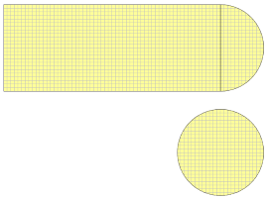

SECOND FLOOR

12 feet

24 feet

24 feet

Dark gray:

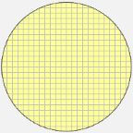

RADIUS

DIAMETER

LENGTH

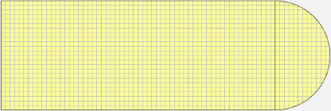

RADIUS

WIDTH

Light gray:

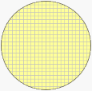

SECOND FLOOR

24 feet

radius = 12 feet

Shape 1:

24 x 60 rectangle

Shape 2:

Semi-circle with

radius = 12

60 feet

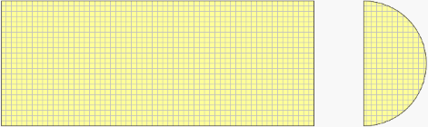

RADIUS

12 feet

24 feet

RADIUS

Dark gray:

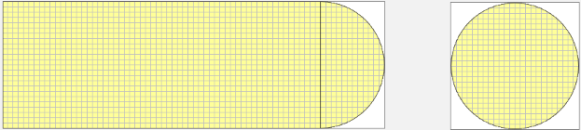

12 feet

60 feet

24 feet

72 feet

24 feet

24 feet

The white boxes for these were added in paint.net